How to set a name and a password for my wireless network
Product line: wireless question category: wireless settings
The Topology is as below:
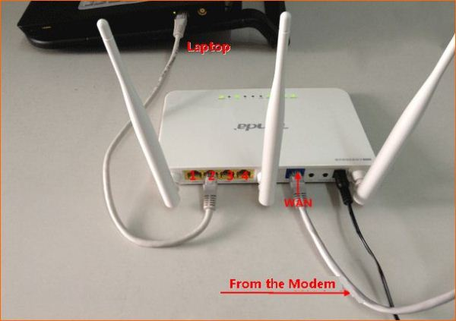

The Steps are as below:
1. Connect your computer to one of the yellow LAN port by an Ethernet cable or just connect to the router wirelessly. (It’s strong suggested that connect to the router by cable, since the wireless settings changed, the old wireless connection will drop out.)
2.Open a browser or safari, then input 192.168.0.1 in the address bar, click Enter.
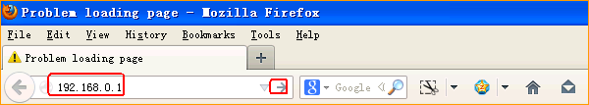

- Input the default login password admin, click OK to go into the homepage.
- Click Advanced, to go into the main page.
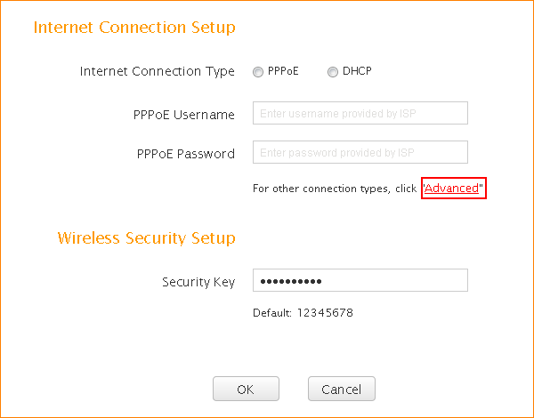

4. Click on Wireless, then set a new name for your WiFi by changing the SSID.

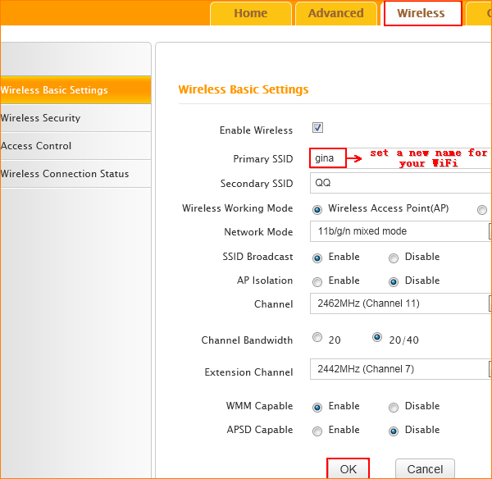

- Set a password for your WiFi
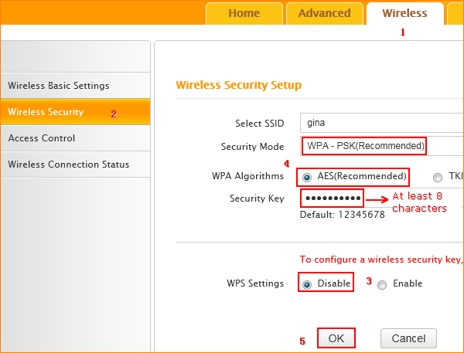

The wireless settings have been done, you can use your wireless devices to scan the new SSID and then input the new security key to connect to it.

How to connect to my Wi-Fi?

